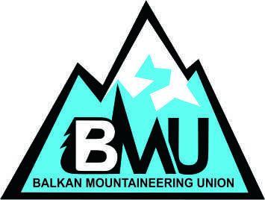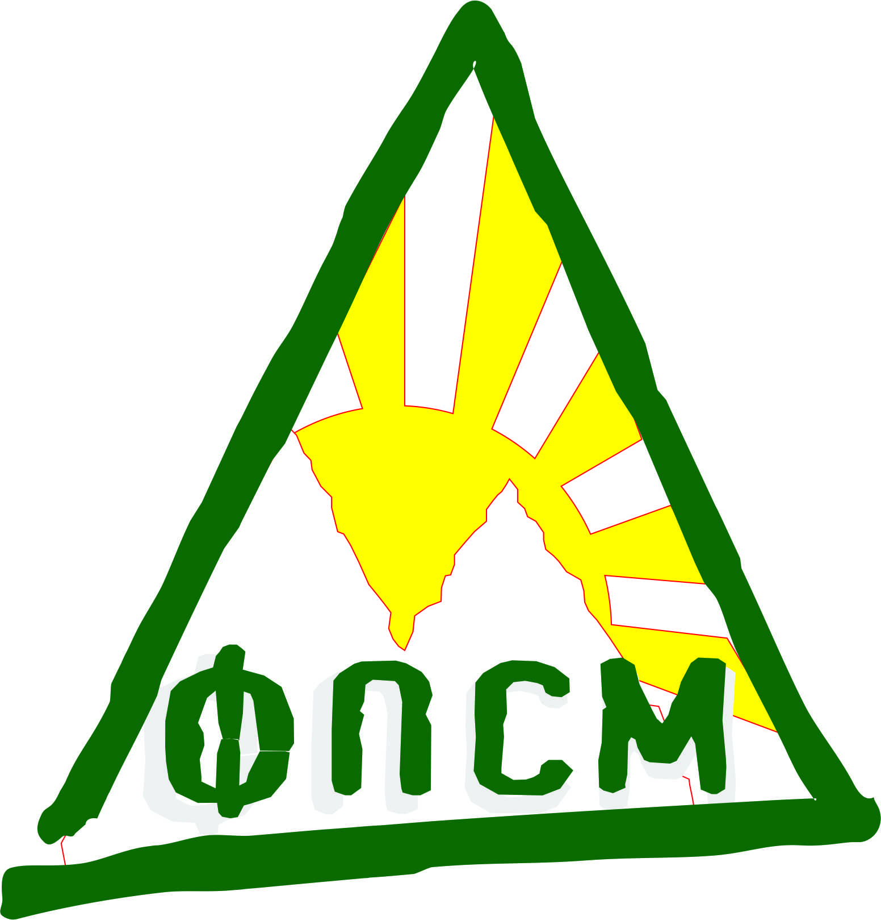

MACEDONIAN MOUNTAIN SPORT FEDERATION
* YOUTH COMMISSION *

INTERNATIONAL YOUTH
TREKKING and CLIMBING
CAMP

GORNA BELICA and
OHRID LAKE (Struga),
Republic of MACEDONIA

20-24 August 2014

The main goal of this youth climbing and trekking camp is to invite climbers to come to Macedonia, to hike through a monument of nature, a national park and to swim in the beautiful Ohrid Lake, while they can also climb and trek in its vicinity. The camp offers climbing in the mystic canyon of “Zli Dol”, trekking to the Jablanica mountain and Galichica peak (2540m) and swimming in the pearly lake.

Date: 20 – 24 August 2014

Place: v. Gorna Belica and Ohrid Lake ( under protection of UNESCO).

Accommodation: v. Gorna Belica mountain hut. Optional, sleeping in tents. Organiser will provide the tents. 2 people per tent.

Food: All meals and lunch packs are provided by the event organiser.

Participants: Young people, age 18-26. Participants should be able to hike 5 ours per day, up to 2.500 m.
We will be offering places to maximum of 3 participants per country federation.
Participants younger than the age of 18 must be accompanied by an adult hiker, who would be able to look after them during this event.

Equipment: Sport attire for trekking, climbing harness, climbing shoes, sun glasses, head torch, water bottles
Recommended: Sun protection, personal medication...
Insurance: Participants should get themselves insurance for accident, rescue, third party liability and travel which is valid for participating in the programme of climbing and trekking. It should be presented to the organisers upon arrival.

Price: GOOD MOOD AND SMILE per participant, payable on arrival to the organiser. Transportation, accommodation, full board, guiding and organisational costs included.

Registration deadline: 13 of August 2014.

Meeting point: SKOPJE and Matka Mountain hut, sport climbing center near Skopje (9 km.). Registration desk for all participants will be in Matka, open on 20th of August, until 15.00h.

Additional information and registration:
Event organisers: Macedonian Mountain Sport Federation - Goran Tintoski mountain guide
E-mail. contact@fpsm.org.mk,
Phone. +389 70 350 342 and +389 70 777 043

About UIAA Global Youth Summit events:
- These events are a great opportunity to meet a varied group of young hikers from home and abroad, and make new friends, as well as exchange hiking techniques.
- During the event we will also share knowledge (demonstrations, lectures and experience) of mountaineering.
- You will also get a great insight into the Macedonian mountaineering traditions and ethics.
- In the event, the camp will provide a platform for international debate and discussion on current topics concerning hiking worldwide. Also we will have a demonstration of some movies and pictures made by Macedonian mountaineers.

Schedule:
Wednesday, 20 th of August 2014
•Arrival of the participants – transport from the airport provided by bus or car. (Confirmation and arrival times of participants needed)
•09:00 – 13:00h Trekking route: The Holy Virgin Monastery – St. Nedela church – St. Andrew or Visit of the Vrelo cave by boat.
•14:00h – Lunch in mountain hut Matka
•Confirmation of registration
•15:00h – Departure for Upper Belica
•Accommodation Upper Belica mountain hut
•20:00h - Dinner
•Meeting – Introduction of the participants and presentation to activities, BMU Organization, Getting acquainted with youth organization within BMU members, Presentation of programme for YML, Lecture on organizing a mountaineering action.

Thursday, 21 th of August 2014
•08:00-09:00h Breakfast
•08:00 – 10:00h Preparation and lecture on mountaineering
•10:00 – 14:00h Crn Kamen – Vevchani (sightseeing and snack) monument of nature
•17:00 – 18:30 Vevchani - Upper Belica
•20:00h – dinner
• Recapturing the day and orientation in nature
Friday, 22nd of August 2014
•07:00-08:00h Breakfast
•08:00h – Preparation and lecture on mapping a mountaineering trail
•10:00h - Departure for village of Radozhda for practical training of orientation in nature, Cultural and mountaineering trail to Kalishta. Continuing to Struga, sightseeing and …
Possibility for water sports.
•15:00 - Lunch
Ohrid, sightseeing and relaxation
Possibility for water sports
•20:00h – dinner
• Recapturing the day and lecture on camp organization and preparation
Saturday, 23th of August 2014
•07:00 - 08:00h Breakfast
•09:00h – Trekking to the Galichica Top (hike through Galicica national park, peak Magaro – 2,254 m., lunch package)
17:00h - climbing and swimming
•20:00 – Barbecue
•Debate – discussion on the previous day’s activities – new skills learned, bigger (newer) experience, rock climbing level

Sunday, 24th of August 2014

•08:00-:00h Breakfast
•09:00h – climbing and swimming
• Lunch and back in..
• 15.00h - Skopje and see you next year!

REGISTRATION FORM
YOUTH MOUNTAINEERING CAMP - BELICA 2014 / 20 – 24.08.2014
FEDERATION: _________________________________________________

address: _____________________________________________________

Phone: _______________________ Fax: _________________________

E-mail: ______________________________

PARTICIPANT:
Name and Family Name |  |  |  |  |  |  |  |  | Sex
Date of Birth |  |  | Email
Address
Telephone |  |  | Fax
Mobile telephone
Emergency home contact number
Passport number |  |  |  | Period of validity
Date of issuing and city
Please indicate your language preferences.
Spoken languages | 1. |  |  |  |  |  | 2.
Special diets: ◻ vegetarian ◻ Eat variety ◻ allergies and intolerances ◻ special diet

Details:
Do you have any Special medical needs or allergies that we should be aware of?

Name and telephone numbers of a person we can contact in the event of an emergency
Participant mountaineering experience:
◻ 1 year ◻ 3 year ◻ 5 year ◻ more...
If you have more participants, please use another copy of this form.

Place, date and time of arrival and transport, which you plan to use:

_______________________________________________________________

Question: ______________________________________________________

Date: __________ Signature____________________________

***Insurance: Participants should have a collective or individual insurance policy, which guaranties covering the expenses of the rescue operations if an accident happens to them in Macedonia. In addition third party liability, accident and travel insurance should be acquired. Please bring a copy of your insurance with you.
Name of the insurance company: ________________________________________
Policy number: ______________________________________________________
Others notes: ______________________________________________________

Participants applying for a YOUTH MOUNTAINEERING CAMP - BELICA event also acknowledge and accept that:
- Safety is a primary concern, but as with all the other forms of climbing there is a danger of personal injury or death;
- Participants and their parents if U18, accept the risks of participation and are responsible for their own actions, which should take account of relevant circumstances such as changing weather conditions.
- To take part it is necessary to be medically fit to do the activity and have valid liability and accident insurance which is valid in the country of the event and which covers rescue and repatriation. Please bring a copy of your insurance with you to show the organizers
Signed
(Participant)______________________________________Date:___________

Izpolnjeno prijavnico pošljite na:
Planinska zveza Slovenije, Mladinska komisija, p. p. 214, 1001 Ljubljana
oz. mladinska.komisija@pzs.si (zadeva: Mednarodni mladinski tabor Makedonija 2014).

