

French Alpine Club FEDERATION - Toulouse
* YOUTH COMMISSION
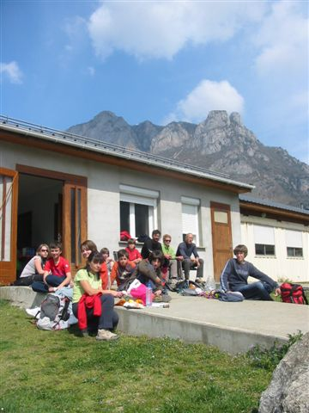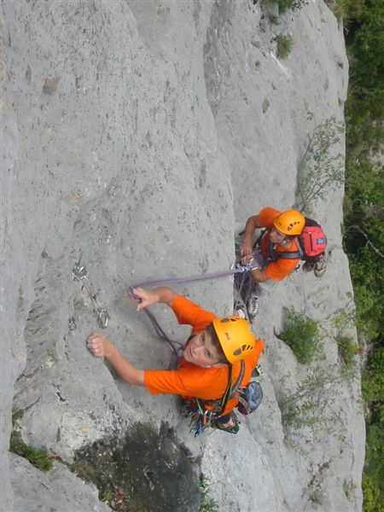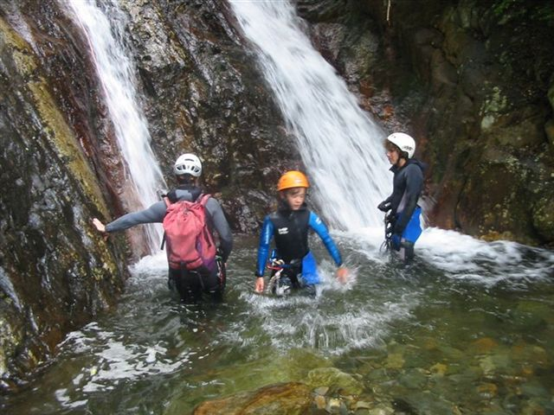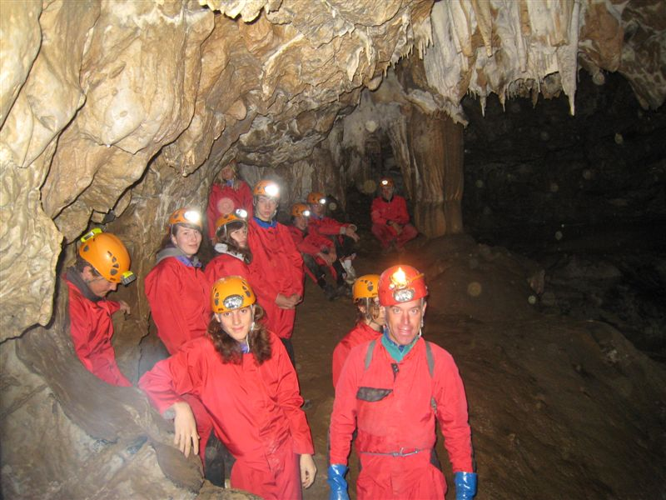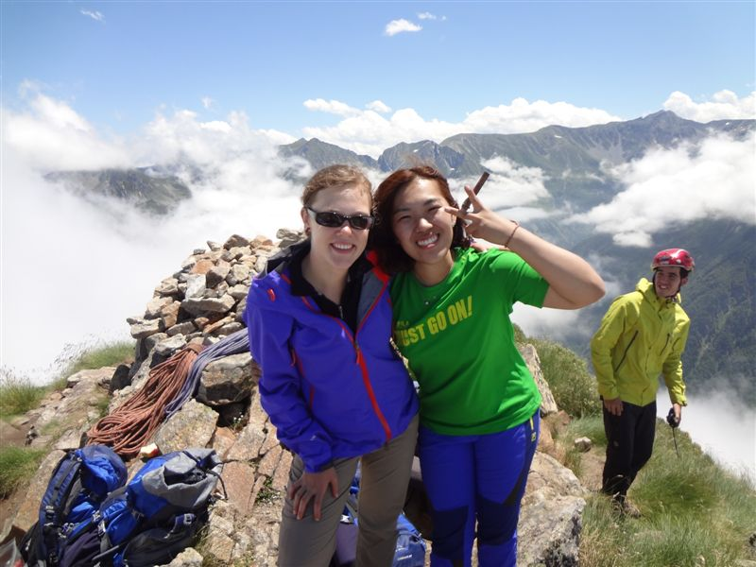

INTERNATIONAL YOUTH CLIMBING CAMP

Ariege, South of France

6-11 July 2013
The main goal of this youth climbing camp is to practice many forms of climbing, cliffs with one pitch, or routes with many pitches, on different types of rock, granite or limestone. It will be also possible also to do canyonning and caving / speleology.

Date: 06 - 11 July 2013. Possible to stay only few days, and to arrive on any day .

Place: Gite Les Oustalous, Les Cabannes (http://www.villagesdebeille.com/oustallous.html ) , Ariège, South of France (distance from 120 KM of Toulouse / one hour and 2 mins)

Accommodation and Food: Rooms for 2 people, all meals and lunch packs are provided by the event organiser and will be prepared by the youth.
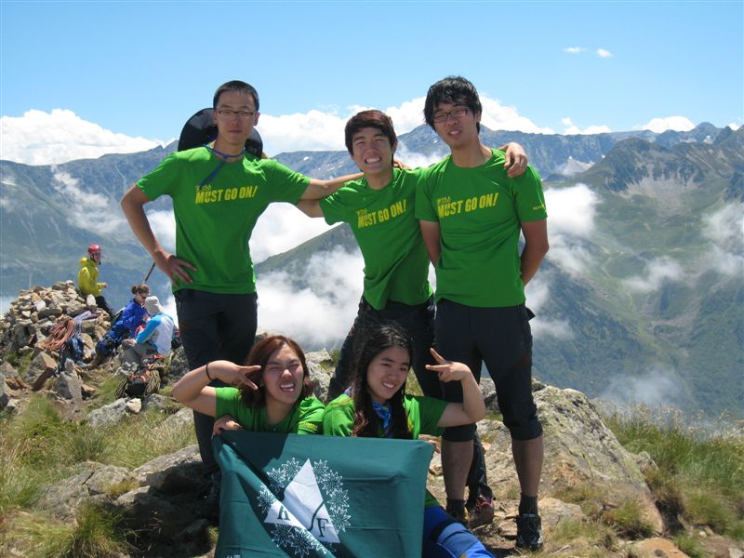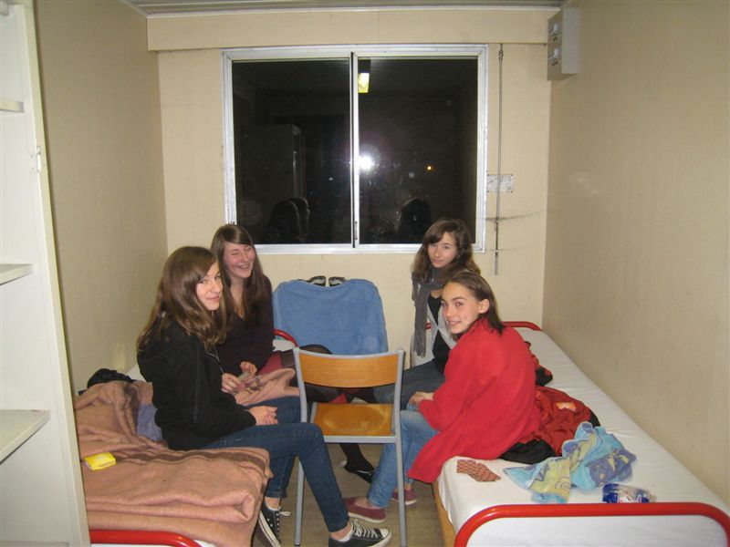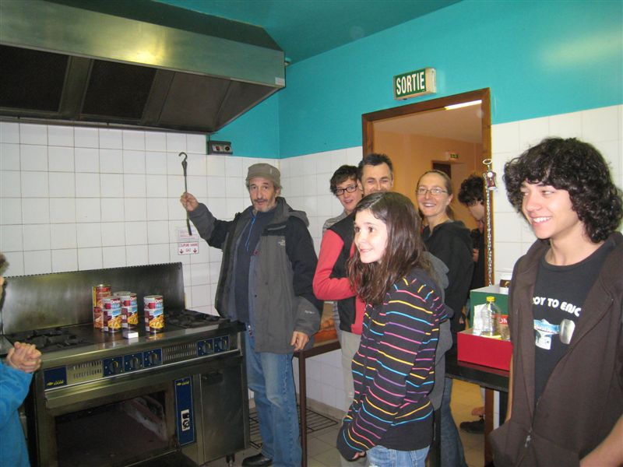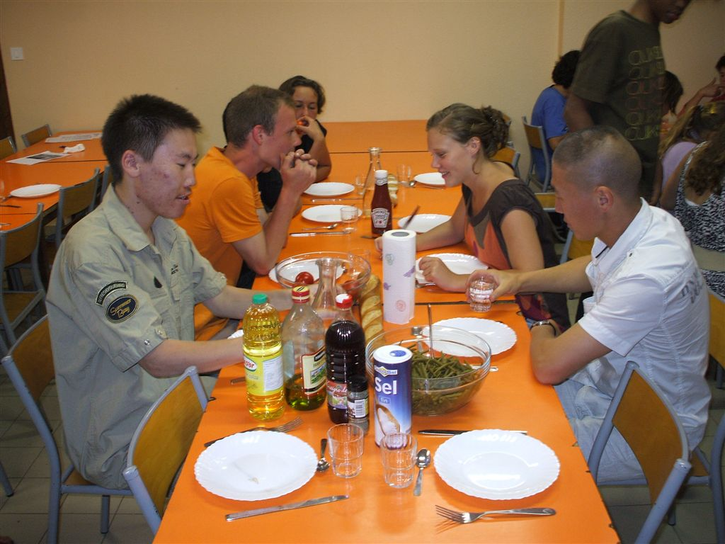

Staff / leaders: all the staff are qualified to supervise this event; instructors Alpinism or Climbing or Canyonning

Participants: Young people from 16 to 22 years old. Participants should lead climb at a minimum of 5b French grade. We will be offering places to maximum of 3 participants per country Federation.
Participants younger than 18 year old must be accompanied by an adult Climber/coach, who is able to look after them during this meet.
Attention: the alcohol consumption by the young people is forbidden during the camp.
Equipment: climbing harness, climbing shoes, chalk bag, climbing helmet, belay device and 10 quick draws (UIAA standard/CEN). Sun glasses & cream, waterproofs, sleeping bag, head torch, climbing clothing and wash kit, water bottle, any personal medication.

Insurance: Participants should get themselves insurance for accident, rescue, third party liability and travel which is valid for participating in the programme of climbing and trekking. This cover note of insurance should be presented to the organisers on arrival.

Entry visas: If your representatives need to obtain entry visa, please confirm their names and passport numbers to the contact emails as soon as possible as Visa processing is a very lengthy process.

Price: 20 EUR per participant / per night, payable on arrival to the organiser. Accommodation, full board, leading and organisational costs included (30 E for accompaniers)

Registration deadline: 22 of June 2013.

Meeting point: Toulouse, on Thursday morning, the 6th of July 2013 (the precise location will be following later depending on how you are arriving i.e. by plane, train etc.*), or another day at the train station “Les Cabannes”

*Place, date and time of arrival and transport, which you plan to use (and number of train or flight) :
- By train in Toulouse Station (or there is a station at Les Cabannes, 3 minutes away from the gite):
- By plane, at the airport of Toulouse Blagnac:

Additional information and registration:
Christian.biard@orange.fr / http://picasaweb.google.fr/bibiaussonne
Member of the National Commissions of Youth and Mountaineering of FFCAM
Member of the Pyrenees Regional Committee
Head of Mountaineering and Youth sections at CAF-Toulouse

About UIAA Global Youth Summit events:
- These events are a great opportunity to meet a varied group of young climbers from home and abroad, and make new friends, as well as exchange climbing techniques.
- During the event we will also share knowledge (demonstrations, lectures and experience) of sport climbing.
- France has one of the best established youth programmes in the world and has had many great mountaineers as well as World Cup winners. We invite you to meet and take advantage of this, sharing your own culture.

Schedule / activities:
The main goal of this youth climbing camp is to practice many forms of climbing, cliffs with one pitch, or routes with many pitches on big walls, on different types of rock, granite or limestone.
All the climbing sites are described on this link: http://cafma.free.fr/
Some pictures of different events / camps on http://picasaweb.google.fr/bibiaussonne,
Camp 2011 on: http://clubalpintoulouse.fr/wikini/wakka.php?wiki=CompteRendu485/caf
Camp 2012 on : http://www.ffcam.fr/index.php?PHPSESSID=j363s4cfq7n5fmad992k8h4oq0&_bdx=&alias=toutes_les_actualites&insidefile=ffcam_actuDetail.html&moid=4&tplentry=br&function=display&oid=T005:4rby4cp532k9#.UAbjB47NL0E

Saturday, 06 th of July 2013: •Arrival about 10 AM of the participants – transport from Toulouse provided by the cars of the staff . (Confirmation and arrival times of participants needed). Confirmation of registration, and accommodation in roms about 12 h 00. Lunch and direction a ciff to climb. 20:00h – dinner

Others days : 08:00-09:00h breakfast, then splitting in groups according climber’s current level of climbing and climbing, or canyoning or caving (lunch at the rock - lunch pack). 20:00h – dinner

Last day, Thursday, the 11 th of July 2013: come back in Toulouse about 07 PM
REGISTRATION FORM
International climbing and trekking camp in Ariège, South of France
July, 6th to 11th of July 2013.

FEDERATION: _________________________________________________

address: _____________________________________________________

Phone: _______________________ Fax: _________________________

E-mail: ______________________________

PARTICIPANT:
Name and Family Name |  |  |  |  |  |  |  |  | Sex
Date of Birth |  |  | Email
Address
Telephone |  |  | Fax
Mobile telephone
Emergency home contact number
Passport number |  |  |  | Period of validity
Date of issuing and city
Please indicate your language preferences.
Spoken languages | 1. |  |  |  |  |  | 2.
Special diets: ◻ vegetarian ◻ Eat variety ◻ allergies and intolerances ◻ special diet

Details:
Do you have any Special medical needs or allergies that we should be aware of?

Name and telephone numbers of a person we can contact in the event of an emergency
Participant climbing experience, level and skills:
I can tie in /Yes/No/ =
* I can top rope belay safely /Yes/No/ = using (belay device)
* I can lead belay safely /Yes/No/ with a (belay device)
My current on sight level is:________ My current red point level is:_______
If you have more participants, please use another copy of this form.
Place, date and time of arrival and transport, which you plan to use (and number of train or flight) :
- By train in Toulouse Station (or there is a station at Les Cabannes, 3 min from the gite):
- By plane, at the aéroport of Blagnac:
_______________________________________________________________
Questions: ______________________________________________________

Name, surname, telephone, fax and e- mail of the person to contact:

________________________________________________________________

Date: __________ Signature____________________________

***Insurance: Participants should have a collective or individual insurance policy, which guaranties covering the expenses of the rescue operations if an accident happens to them in France. In addition third party liability, accident and travel insurance should be acquired. Please bring a copy of your insurance with you.
Name of the insurance company: ________________________________________
Policy number: ______________________________________________________
Others notes: ______________________________________________________

Participants applying for a UIAA Global Youth Summit event also acknowledge and accept that:
- Safety is a primary concern at UIAA Global Youth Summit Events, but as with all the other forms of climbing there is a danger of personal injury or death.
- Participants at UIAA Global Youth Summit events, and their parents if younger than18, accept the risks of participation and are responsible for their own actions, which should take account of relevant circumstances such as changing weather conditions.
- To take part it is necessary to be medically fit to do the activity and have valid liability and accident insurance which is valid in the country of the event and which covers rescue and repatriation. Please bring a copy of your insurance with you to show the organizers

The alcohol consumption by the young people is forbidden during the camp.

Signed: (Participant)____________________________Date:___________

Please send this registration form through
Club Alpin Français de TOULOUSE , 3 rue de l'Orient - 31000 TOULOUSE France
Attention to C BIARD, Youth Commission*
before ending 22 June 2013.
Contacts
Club Alpin Français de TOULOUSE , 3 rue de l'Orient - 31000 TOULOUSE France .: 05-61-63-74-42
Fax : 05-61-63-96-60 / clubalpintoulouse@wanadoo.fr / http://clubalpintoulouse.fr/
Christian BIARD christian.biard@orange.fr / christian.biard@orange.com / + 33 682 33 86 63

