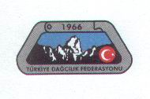
Türkiye Dağcilik Federasyonu
Turkish Mountaineering Federation

TDF/ / /2013

Dear President,

You and your delegation are cordially invited to the 14th International Victory climb to Mount Ağrı (Ararat) which will be held at August 27–September 01, 2013
We would be pleased if you and your Federation members attend to this activity.

Yours sincerely,
Alaattin KARACA
President of Turkish Mountaineering Federation

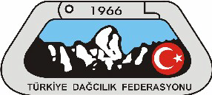
14th INTERNATIONAL AUGUST 30TH VICTORY CLIMB TO MOUNT AĞRI
AUGUST 27–SEPTEMBER 01, 2013. DOĞUBEYAZIT/AĞRI

GENERAL INFORMATION:14th International Victory Climb to Mount Ağrı , organized by Turkish Mountaineering Federation (TMF) will be executed on August 27– September 01, 2013. TMF has honor to invite (4) mountaineers of your Federation/ Association.
Due to limited capacity and weather conditions, TMF has right to change the schedule of the program and to keep the number of nominees at an acceptable level if, however, more than expected.
PARTICIPANTS : This invitation is sent to International Federations or Associations, and from each of them TMF kindly asks to nominate four (4) mountaineers not later than August 15th, 2013.
The Mount Ağrı with its (5165) meters altitude needs at least basic experience concerning snow and glacier climbing techniques but also, necessary camp and climbing equipments such as sleeping bag, tent, ice axe, crampons (if you want to choose glacier route) etc.
Please fill and send “application forms” attached here, along with personnel information of your mountaineers (not more than 4).
HOW TO REACH DOĞUBEYAZIT : You can find cheap flight from İstanbul to Ağrı or Iğdır . There are approximately 2 direct flights from Istanbul to Ağrı (TZX) and 2 flights from Ankara to Ağrı or Iğdır every day. It is important buying the tickets as early as possible; because the tickets are cheaper at earlier convenience especially in summer season. Otherwise the flight tickets are expensive in Turkey during summer season. You can find below the web addresses for buying the tickets. Be carefully there are 2 airports in Istanbul. These are:
1-IST (Atatürk Airport) http://www.ataturkairport.com/en-EN/Pages/Main.aspx
2-SAW (Sabiha Gökcen Airport ) http://www.sgairport.com/havaalani/eng/start.asp
Airlines Companies: (flight 2 hour 10 min. from İstanbul to Ağrı or Iğdır)
THY http://www.turkishairlines.com
Pegasus http://www.flypgs.com/en/
Onur Air http://www.onurair.com.tr/default_eng.aspx
Anadolu Jet http://www.anadolujet.com/aj-EN/index.aspx
You can easily find mini buses and/or service bus in front of Ağrı, Iğdır airport from Ağrı, Iğdır to Doğubeyazıt city center.
On the other hand, as TMF we will also secure a minibus for carrying the participants from Ağrı, Iğdır to Doğubeyazıt two times a day. It is necessary for the participants give their flying schedule to our federation not later four weeks before the flying time.
For those of you who prefer to travel from İstanbul to Ağrı by Busses:
Bus Companies: (approximately 20 hours from İstanbul to Doğubeyazıt)
Ulusoy http://www.ulusoy.com.tr/
Metro http://www.metroturizm.com.tr/en/index.htm
FINANCIAL CONDITIONS: All organizational services, official permission and guidance will be provided by TMF. Travel and accommodation expenses will be covered by each participant. All delegations are kindly asked to bring their national flags together with them.
Doğubayazıt, set on a stark treeless plain between ranges of craggy mountains, is the last Turkish town on the highway to Iran.
The border, 35km (22 miles) to the east, helps to define the role that Doğubayazıt (doh-OO-bah-yah-zuht, alt. 1950 meters/6400 feet, pop. 36,000) played in history, as does the striking 18th-century Ishak Pasha Palace 5 km (3 miles) to the east.
You will visit to gaze upon legendary Mount Ararat, or the giant meteor crater 4 km (2.5 miles) west of the border, or Eski Beyazıt, the foundations of a settlement thought to date from Urartian times (800 BC).
Mount Ararat (Turkish: Ağrı, see below other: names and etymology) is a snow-capped, dormant volcanic cone in Turkey. It has two peaks: Greater Ararat (the highest peak in Turkey, and the entire Armenian plateau with an elevation of (5,137 m or 16,854 ft) and Lesser Ararat (with an elevation of 3,896 m or 12,782 ft).
The Ararat massif is about 40 km (25 mi) in diameter. The Iran-Turkey boundary skirts east of Lesser Ararat, the lower peak of the Ararat massif. It was in this area that, by the Tehran Convention of 1932, a border change was made in Turkey's favor, allowing it to occupy the eastern flank of Lesser Ararat.^{[5]} Mount Ararat in Judeo-Christian tradition is associated with the "Mountains of Ararat" where, according to the book of Genesis, Noah's ark came to rest.
It also plays a significant role in Armenian culture and irredentism. The mountain can be seen on the Coat of arms of Armenia.
DAILY SCHEDULE:
Day 1: Dogubayazit to Mount Ararat (first Camp):
Starting of this trip will be from Van airport. You will meet our staff in the airport to transfer the group to our starting point for the expedition “Mount Ararat plain”.
Have our lunch in Dogubeyazit and after the gear check we will be transferred to the 2100 m Elli village in the Mount Ararat to start our expedition.
Mules will carry our expedition equipments up to the nomadic camping area in 2850 m or 3200m. Here we will be staying with local villagers and enjoy all day with discovering the people and mountain.
Day 2: second Camp at Ararat, 4200m.:
Today we will move our tents and equipments from 3200m. or Sandy camp to 4200 m. second camp. Well after the setting our new camp we will ascent to approximately 4700 m. to acclimate for next day summit ascent. Well in our trek if the weather is visible you will see the gorge between little and great Ararat Mountains and watch the Ararat plain.
After having our meal at high altitude we will return to our new camp 4200 m.
Day 3: Mount Ararat Summit Day:
On the third day, we will wake up very early before the sun rises up. We will have our little breakfast in the moon light with seeing the city lights down in the plane of Mount Ararat.
Start our ascent with in moon light and on our half way to the summit we’ll have a brake and at this time you will see the shadow of the mountain in the plane. Before we get to the summit we will meet with the biggest glacier of Turkey at this point we will use our crampons till to the summit approximately 300 m.
When we get to the summit of 5137 m you will feel an empty space in your heart at the same time feel the happening of being in the summit.
After the celebration of being at the summit, we will start trek down to the 4200 m and base camp. Then we will spend our time in the 3200 m. relaxing.
Day 4: Back to Dogubayazit:
The day of saying goodbye to the Holly Mount Ararat; after having our breakfast we will walk down from 3200 m base camp down to 2100 m. to get the transport to the hotel in the center of the town.
Useful Links
www.tdf.org.tr; www.thy.com

Climbing Routes:
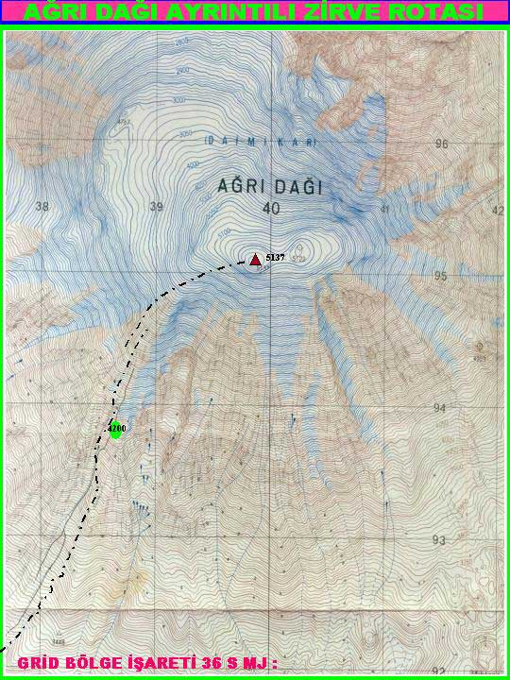

EMAİL ADDRESS:
"turkish mountaineering federation" <tdf1966@hotmail.com>,

13th INTERNATIONAL AUGUST 30TH VICTORY CLIMB TO
MOUNT AĞRI
AUGUST 28 – SEPTEMBER 01, 2013, AĞRI/TÜRKİYE

APPLICATION FORM

COUNTRY :

Name of Association / Federation :
Phone : |  | Fax :
E-Mail :
Names of Participants

Name | Surname | Address | Phone
Name | Surname | Address | Phone
Date of Arrival :
Date of Departure :
Type of Room Single Double Room Room for 3
Flight Details (Flight Number , Arrival and Departure Date) :

Date , Signature of
President or Secretary
General and Stamp of Association

Please return this form to Turkish Mountaineering Federation until 15 AUGUST, 2013
By Fax : 00 90 312 310 15 78 – Phone : 00 90 312 311 91 20
E-Mail : tdf1966@hotmail.com
Address : Gençlik ve Spor Genel Müdürlüğü Dağcılık Federasyonu Başkanlığı Ulus İş Hanı A Blok Kat 4 Ulus / Ankara / TURKEY

